**PHP e-Project**

***Online Shopping Cart***

**Submitted To**

[eprojects@aptech.ac.in](mailto:eprojects@aptech.ac.in)

**Project Instructor**

Miss Tehreem Mushtaq

**Curriculum Code**

6740

**Group Members**

*Abdalullah Sheikh*

*Student1286264*

*Ahmad Zafer  
Student1286650*

*Abdul Mueed  
Student1291743*

*Kashan Ahmad   
Student1285717*

*Tameem Shaikh  
Student1274626*



# 

***Online Shopping Cart***

**Table of Contents**

*ACKNOWLEGDMENT* *3*

*PROJECT CERTIFICATION* *4*

*INTRODUCTION TO ONLINE SHOPPING CART* *5*

*REQUIRMENT SPECIFICATION* *5*

*(A) HARDWARE REQUIRMENT* *5*

*(B) SOFTWARE REQUIRMENT* *5*

*SITE DEFINATION* *6*

*HOME PAGE (Detail)* *7*

*ABOUT US (Detail)* *8*

*SERVICE PAGE (Detail)* *6*

*CONTACT US (Detail)*7

# ACKNOWLEDGEMENT

***W***

*e are thankful to Almighty, ALLAH that by His grace we have been successful. we presenting on* ***Visual Studio Code*** *in your hands. We have tried our best to take all relevant important topics in consideration so that this project may become comprehensive.*

*This is our* ***Third Semester E-project****. We have tried our best & struggled for a better outlook to come. This project has been developed in* ***Visual Studio Code using PHP.*** *We choose to make Webpage for* ***ONLINE Shopping Cart*** *as a project. We find easy to do coding in* ***Visual Studio Code.***

*We earnestly hope that this project will provide all the necessarily information required for the user to fulfill their inspiration. However suggestions for improvement of the project will be thankful received & acknowledge.*

# *Online Shopping Cart*

**THANKING YOU……**

# *Online Shopping Cart*

# Project Certification

*This is to certify that,*

***Abdalullah Shiekh, Ahmad Zafer, Abdul Mueed, Kashan Ahmad,Muhammad Tameem Shaikh***

*as successfully Designed &Developed*

***“Online Shopping Cart”***

*Date of Issue: 11-Jun-2022*

***Authorized Signature: Tehreem Mushtaq***

# “INTRODUCTION TO

# ONLINE SHOPPING CART”

The thirst for learning, upgrading technical skills and applying the concepts in real life environment at a fast pace is what the industry demands from IT professionals today. However busy work schedules, far-flung locations, unavailability of convenient time-slots pose as major barriers when it comes to applying the concepts into realism. And hence the need to look out for alternative means of implementation in the form of laddered approach.

The above truly pose as constraints especially for our students too! With their busy schedules, it is indeed difficult for our students to keep up with the genuine and constant need for integrated application which can be seen live especially so in the field of IT education where technology can change on the spur of a moment. *Well, technology does come to our rescue at such times!!*

Keeping the above in mind and in tune with our constant endeavour to use Technology in our training model, we at Aptech have thought of revolutionizing the way our students learn and implement the concepts using tools themselves by providing a *live and synchronous eProject learning environment!*

**So what is this eProject?**

eProject is a step by step learning environment that closely simulates the classroom and Lab based learning environment into actual implementation. It is a project implementation at your fingertips!! An electronic, live juncture on the machine that allows you to

* Practice step by step i.e. laddered approach.
* Build a larger more robust application.
* Usage of certain utilities in applications designed by user.
* Single program to unified code leading to a complete application.
* Learn implementation of concepts in a phased manner.
* Enhance skills and add value.
* Work on real life projects.
* Give a real life scenario and help to create applications more complicated and useful.
* Mentoring through email support.

The students at the centre are expected to complete this eProject and send complete documentation with source code to eProjects Team

Looking forward to a positive response from your end!!

**REQUIREMENT SPECIFICATION:**

You need to complete your project and submit the following by the end-date.

              I.      Working Application

a.       Source Code

b.      Compiled Code

           II.      **E-Project** Report

n       **E-Project** Report should comprise-

q      Acknowledgements

q      **E-Project** Synopsis

q      **E-Project** Analysis

q      **E-Project** Design

n       DFD’s

n       Flow Charts

n       Process Diagrams

n       Database Design / Structure

q      Screen Shot’s

q      Source Code with Comments

q      User Guide

q      Developer’s Guide

n       Module Descriptions

* *User Guide means User Manual, it should have details how a user can operate the application.*
* *Developer’s Guide should have detail description of the modules, so that any developer can look into the code and get to know about it through the Developer’s Guide.*

**HARDWARE REQUIRMENT :**

* A minimum computer system that will help you access all the tools in the courses is a Pentium 166 or better
* 128 Megabytes of RAM or better

**Software Requirements :**

* PHP
* MySQL
* PERL
* Apache

*DEVELOPER GUIDE :*

|  |  |  |
| --- | --- | --- |
| **No.** | **Items** | ***Description*** |
| 1 | Operating System | Window 10 |
| 2 | Main processor | Minimum 166 or better |
| 3 | Ram (Memory) | Minimum 64 or better |
| 4 | Web Browser | Google Chrome/Firefox |
| 5 | Software | Visual Studio Code |

**System Requirement:**

*SITE MAP :*

***Online Shopping Cart***

ABOUT

SERVICE

HOME

CONTACT

PRICE

BLOG

FAQ

LOGIN

Cart

**HOME PAGE:**

**Home Page Is Available on all pages**

**You can add more image in slider**

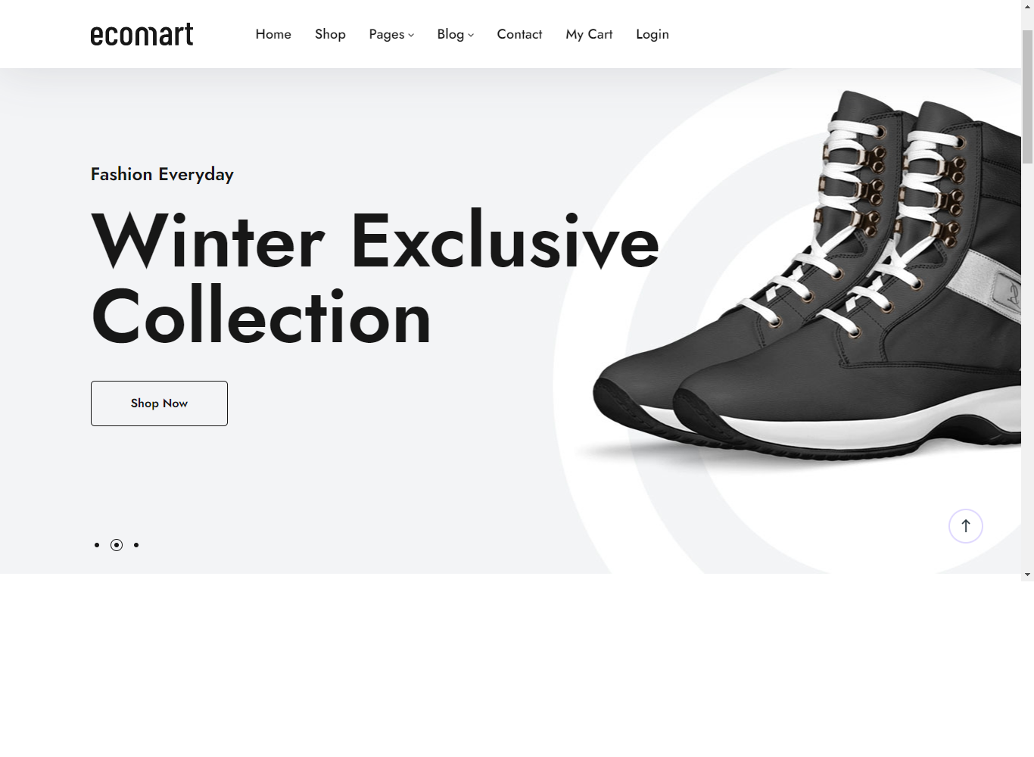

<!-- Slide 1 -->

<li data-transition='fade' data-rotate='0' data-saveperformance='off'>

<img src="~/images/slider/slide1.jpg" alt="slide1" data-bgposition="center center" data-bgfit="cover" data-bgrepeat="no-repeat" class="rev-slidebg">

<!-- 1-1-image -->

<div class="tp-caption tp-scale" id="slide-1-1" data-x="['center','center','center','center']" data-hoffset="['-480','-300','-248','-192']" data-y="['top','top','top','top']" data-voffset="['0','0','0','0']" data-width="['961','601','497','385']" data-height="['778','486','402','311']" data-whitespace="nowrap" data-type="image" data-basealign="slide" data-responsive_offset="on" data-frames='[{"from":"o:0;","speed":1000,"to":"o:1","delay":0,"ease":"Power2.easeInOut"},{"delay":"wait","speed":1500,"to":"x:left;","ease":"Power2.easeInOut"}]' style="z-index: 1;">

<img src="~/images/slider/slide1-1.jpg" alt="">

</div>

<!-- 1-2-image -->

<div class="tp-caption tp-scale" id="slide-1-2" data-x="['center','center','center','center']" data-hoffset="['480','300','248','192']" data-y="['top','top','top','top']" data-voffset="['0','0','0','0']" data-width="['961','601','497','385']" data-height="['778','486','402','311']" data-whitespace="nowrap" data-type="image" data-basealign="slide" data-responsive_offset="on" data-frames='[{"from":"o:0;","speed":1000,"to":"o:1","delay":0,"ease":"Power2.easeInOut"},{"delay":"wait","speed":1500,"to":"x:right;","ease":"Power2.easeInOut"}]' style="z-index: 1;">

<img src="~/images/slider/slide1-2.jpg" alt="">

</div>

**ABOUT US:**

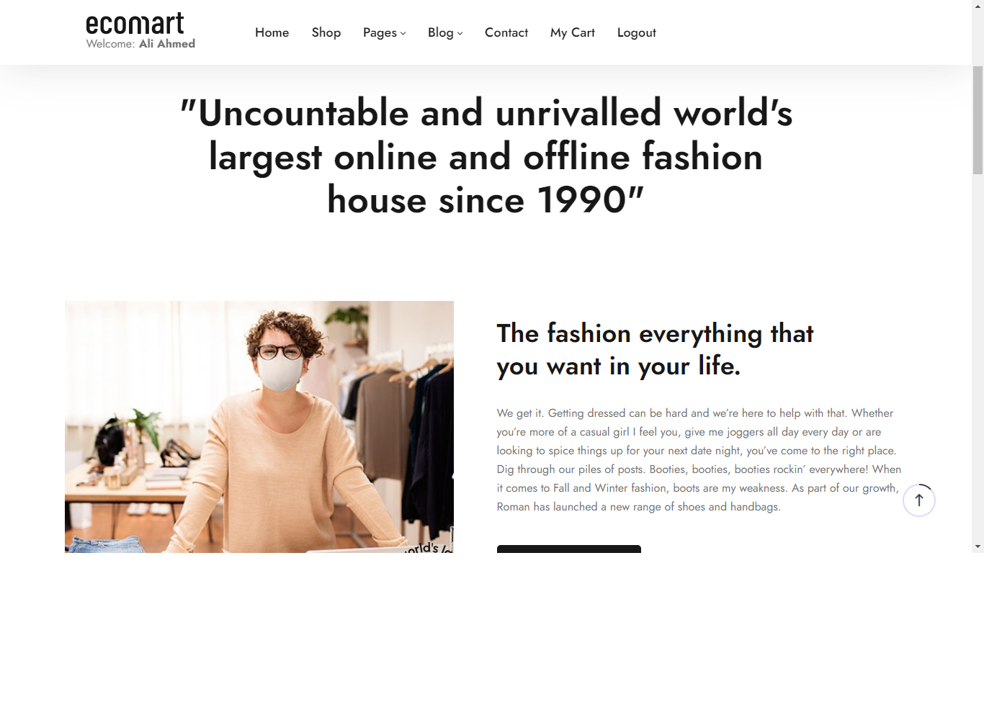

**SERVICE PAGE:**

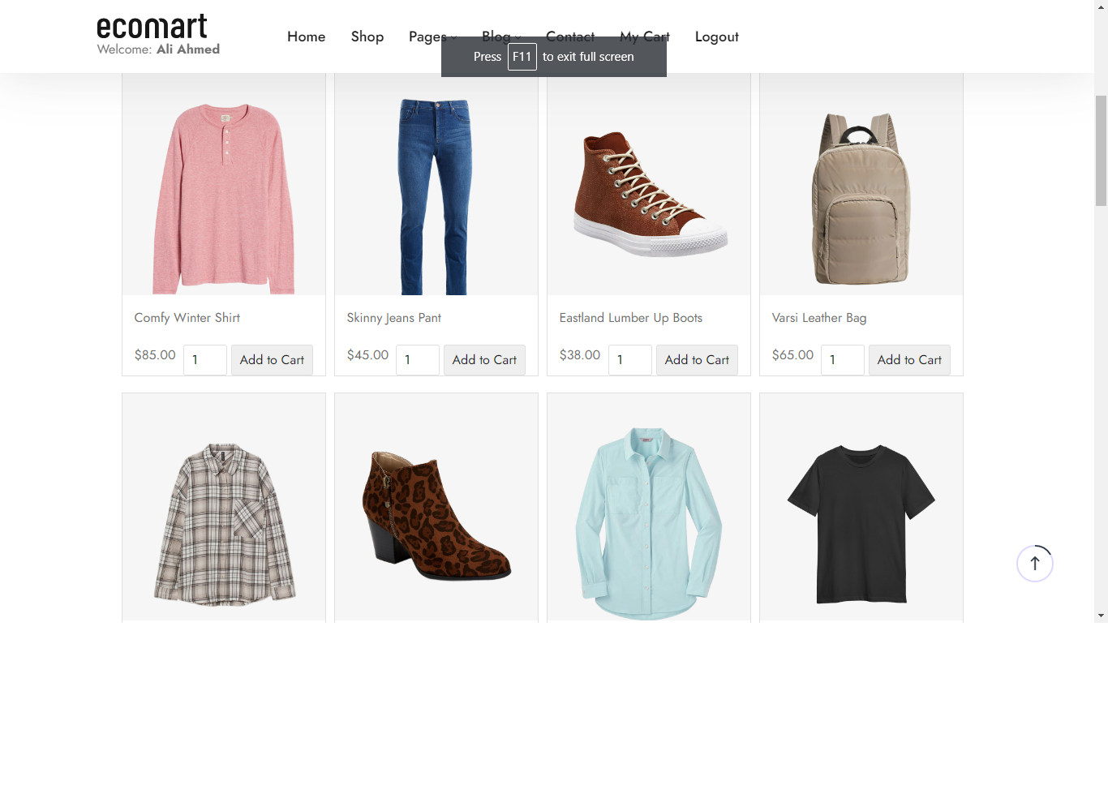

<ul class="circle-list three-col collapsed" id="clientsList">

<li>Comfy Winter Shirt</li>

<li>Skinny Jeans Pant</li>

<li>Eastland Lumber Up Boots</li>

<li>Varsi Leather Bag</li>

<li>Fit Twill Shirt for Woman </li>

<li>Grand Atlantic Chukka Boots</li>

<li>Women's Faux-Trim Shirt</li>

<li>Soft Touch Interlock Polo</li>

<li>Ecomart Smart Watch</li>

<li>Ecomart Smart Glass</li>

<li>Cotton Shirt fot Men</li>

<li>Double-breasted Blazer</li>

<li>Ribbed Cotton Bodysuits</li>

<li>Men's Tricot Track Jacket</li>

<li>Wedding Diamond Ring</li>

<li>Men's Classic Fit Polo</li>

<li>Girls Metallic Coat</li>

<li>Packable Quilted Puffer Jacket </li>

<li>Men's Classic Stretch Shirt</li>

<li>Denim Official Coat</li>

<li>Skinny Cotton Pant</li>

<li>Fit Twill Shirt for Woman</li>

<li>Baby Dress for Girl</li>

</ul>

**contact us:**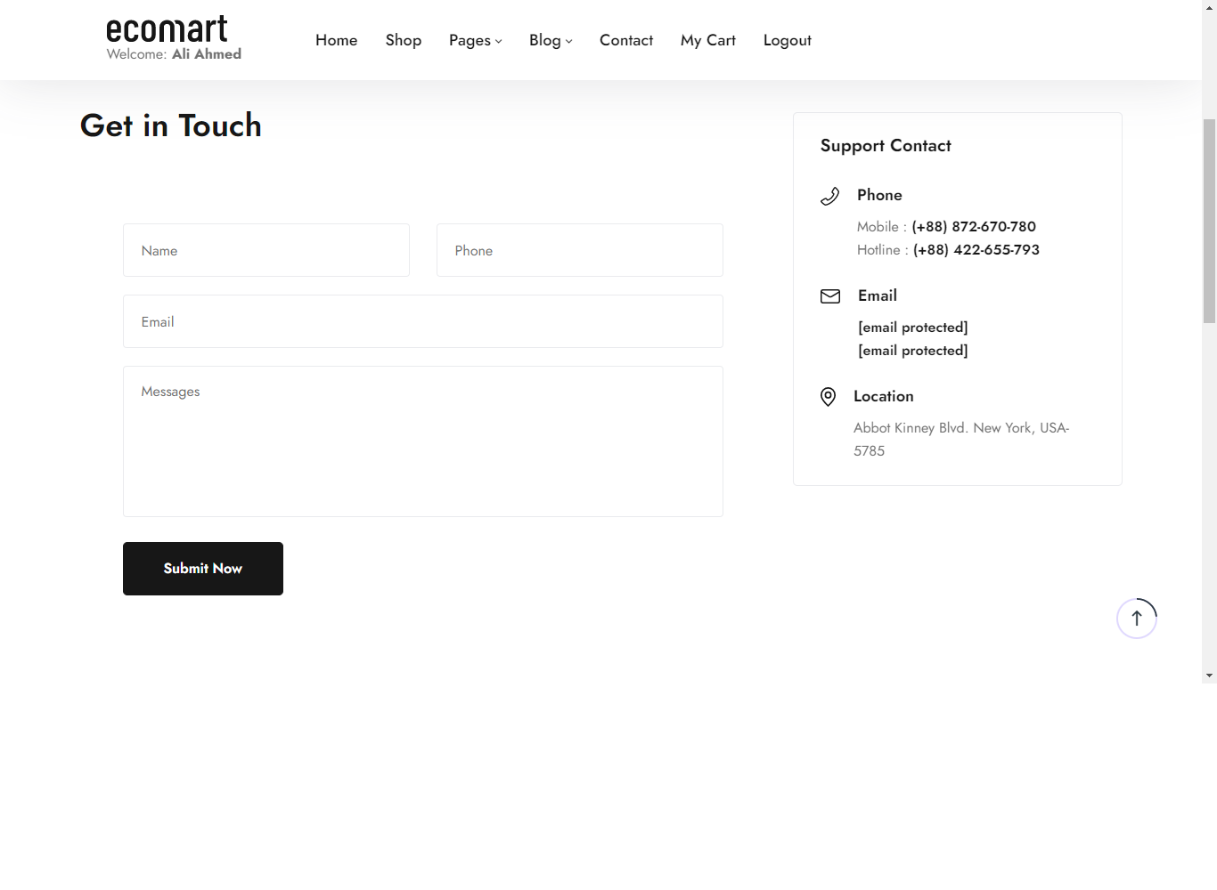

<div class="container">

<h1 class="title-underline">Contact Us</h1>

<div class="row">

<div class="col-sm-5 col-md-4 col-lg-4">

<div class="contact-box-01">

<h6 class="title">Our address:</h6> 5604 Willow Crossing Ct,

<br> Clifton, VA, 20124

</div>

<div class="contact-box-02">

<h6 class="title">Call us:</h6> +1-800-123-45-67

</div>

<div class="contact-box-03">

<h6 class="title">Have any questions?</h6>

<a href="mailto:noreply@envato.com">noreply@envato.com</a>

<br>

<a href="www.envato.html">www.envato.com</a>

</div>

**DATABASE:** 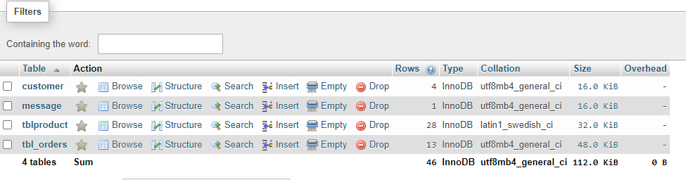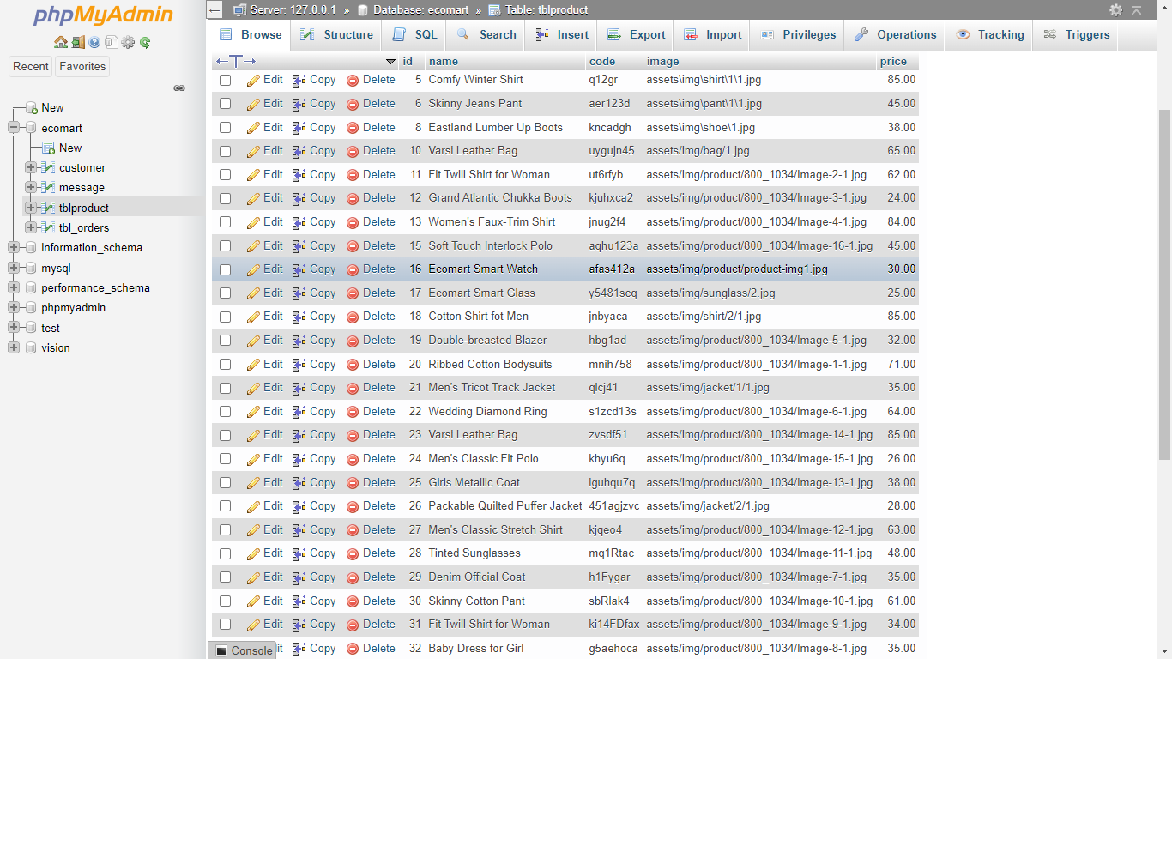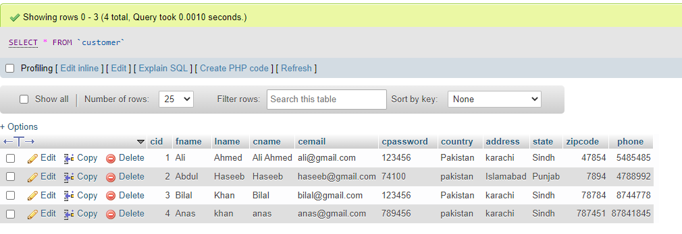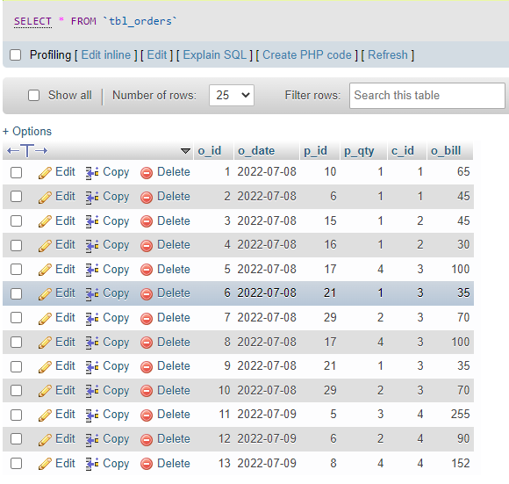

**ERM